The effect of dispersion, sorption and degradation on contaminant spreading

The effect of mechanical dispersion, sorption and degradation on the spreading of a contaminant plume is schematically presented in Figures 1, 2 and 3, respectively. Each figure focuses on how each contaminant transport mechanism changes at a specific time, t, following an instantaneous contaminant release from a point source and shows (a) the shape and size of the developed contaminant plume, and (b) the location and the magnitude of the peak aqueous concentration. The plume is represented by three curves of equal concentration, which are confocal ellipses delineating the area occupied by the contaminant-containing fluid. The parameters used for the four simulations are presented in Table 1. The data of the reference case match the data of the carbon tetrachloride release at the Borden site that is described in Mackay et al. (1986) and Roberts et al. (1986).

Table 1. Parameters used for the reference case and the simulations with increased (a) mechanical dispersion, (b) sorption, and (c) degradation
Parameter | Units | Value
 |  | Reference simulation | Increased mechanical dispersion | Increased sorption | Increased degradation
Solute Mass, M ª | [g] | 0.370 | 0.370 | 0.185 | 0.370
Soil porosity, n | [-] | 0.330
Longitudinal dispersivity, a_{x} | [m] | 0.300 | 0.700 | 0.300 | 0.300
Transversal dispersivity, a_{y} | [m] | 0.060 | 0.090 | 0.060 | 0.060
Transversal dispersivity, a_{z} | [m] | 0.003
Molecular diffusion coefficient, D_{e} | [m²/d] | 0.6 10⁻⁴
Horizontal seepage velocity, v_{x} | [m/d] | 0.081
Partition coefficient, K_{p} | [cm³/g] | 0.164 | 0.164 | 0.510 | 0.164
Bulk density of the soil, ρ_{d} | [g/cm³] | 1.810
Retardation coefficient, R ^{b} | [-] | 1.900 | 1.900 | 3.800 | 1.900
Decay coefficient, λ | [d⁻¹] | 0.004 | 0.004 | 0.004 | 0.009
ª: For every simulation it is assumed that a total solute mass of 0.70 g has been released from the point source. In the calculations solute mass, M, corresponds to the mass contained within the aqueous phase of the soil. Hence, a smaller mass M was calculated for the case of increased sorption, due to the elevated partition coefficient.
^{b}: The retardation coefficient R in the reference case is higher than 1 for carbon tetrachloride. Hence, the retarded advection velocity is u / R₁ in the reference case and u / 2R₁ in the case with increased sorption, with Κ_{p2} = 3.1K_{p1}. In order to simplify the presentation, herein the retardation in the reference case is not mentioned, as if R₁ = 1.

The effect of dispersion
Figure 1a shows the results of a reference simulation, where the concentration peak, C_{max,ref}, has advanced with groundwater flow at a seepage velocity u and is located at a distance X_{ref} = u t from the point source location. In Figure 1b, where mechanical dispersion is elevated, the area occupied by the contaminant has grown longitudinally and transversely. As the contaminant mass (which is the same for both cases presented in Figures 1a and 1b) has now spread in a larger part of the flow domain, the peak concentration, C_{max,dis}, has been reduced. The center of the three ellipsoidal curves of equal concentration is the same in both simulations, i.e. X_{ref} = X_{dis}, since it has advanced at the same steady-state flow velocity u.

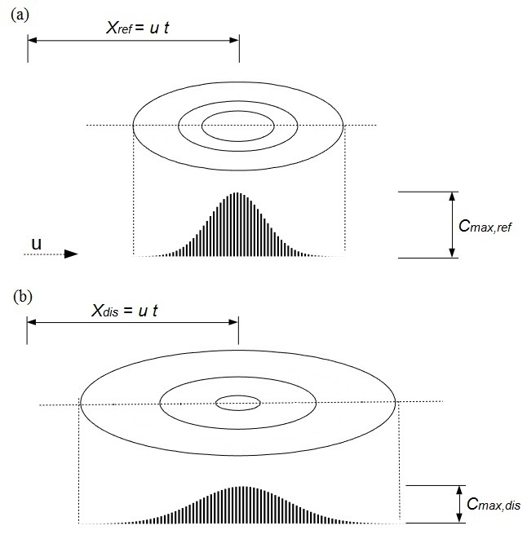
Figure 1. Illustration of the effect of increased mechanical dispersion on the contaminant spreading following an instantaneous solute release from a point source. Contours are drawn at concentrations equal to C, 100C, 400C.

The effect of sorption
The effect of sorption is to decelerate the advance of the contaminant. In the case of increased sorption (Figure 2b), the contaminant advances at a retarded mean fluid velocity, u / R, where R is the retardation coefficient. Consequently, the center of the ellipsoidal curves of equal concentration (i.e. the center of the plume) has progressed to a distance X_{sor}, which is smaller than the corresponding distance X_{ref} of the reference simulation (Figure 2a). What is more, due to the increase in sorption, the contaminant will be dispersed within the porous medium at a decreased dispersion coefficient as well. Consequently, the plume in Figure 2b occupies a smaller area of the flow domain. Since part of the released contaminant mass is sorbed onto the solid matrix, the peak concentration in the aqueous phase, C_{max,sor}, is smaller than C_{max,ref}.

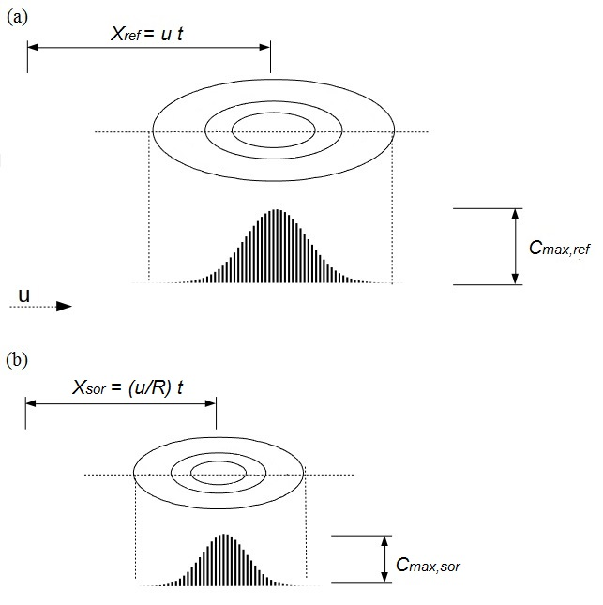
Figure 2. Illustration of the effect of increased sorption on the contaminant spreading following an instantaneous solute release from a point source. Contours are drawn at concentrations equal to C, 100C, 400C.

The effect of degradation
Figure 3 shows the effect of degradation. Degradation expresses a decrease in the mass of the contaminant present in the aqueous phase over time. As a result, at time t, the region occupied by the solute-containing fluid is diminished (the effect is clear on extent of the two inner contours of equal concentration, whereas the outer is only slightly smaller). The concentration peak is located at X_{deg}, which is equal to X_{ref}, but the magnitude of the concentration peak, C_{max,deg}, is lower than C_{max, ref}.

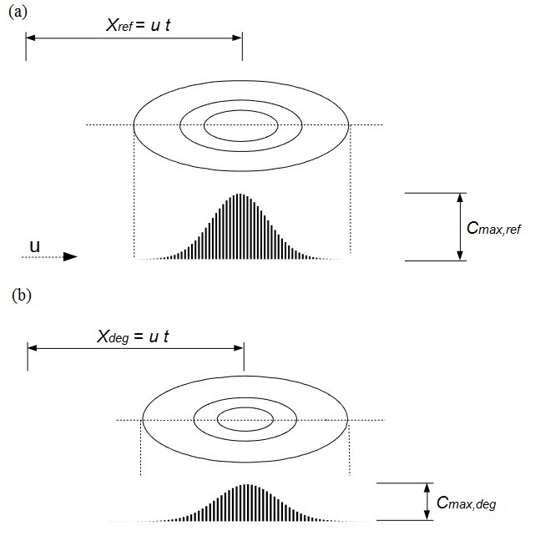
Figure 3. Illustration of the effect of increased degradation on the contaminant spreading following an instantaneous solute release from a point source. Contours are drawn at concentrations equal to C, 100C, 400C.

Figure 4 provides a summary that compares contaminant distribution in the reference case (Figure 4a corresponds to Figures 1a, 2a, 3a) with the contaminant distributions when the intensity of transport phenomena increases, i.e. increased mechanical dispersion (Figure 4b corresponds to Figure 1b), increased sorption (Figure 4c corresponds to Figure 2b), and increased degradation (Figure 4d corresponds to Figure 3b).

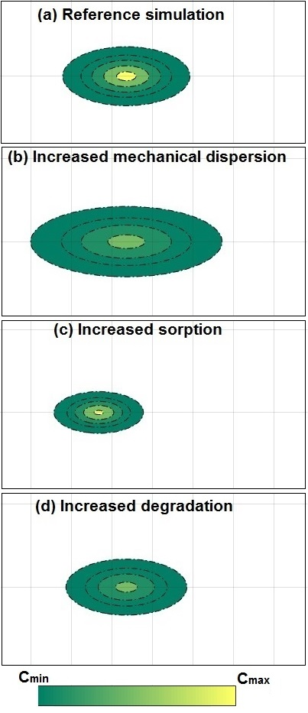
Figure 4. (a) Illustration of the contaminant plume spreading following an instantaneous release from a point source and illustration of the effect from increased (b) mechanical dispersion, (c) sorption and (d) degradation. C_{max} = 1500C_{min}.
References

Mackay, D.M., D.L. Freyberg and P.V. Roberts, 1986, A natural gradient experiment on solute transport in a sand aquifer 1. Approach and overview of plume movement, Water Resources Research, 22:13:2017-2029

Roberts, P.V., M.N. Goltz and D.M. Mackay, 1986, A natural gradient experiment on solute transport in a sand aquifer 3. Retardation estimates and mass balances of organic solutes, Water Resources Research, 22:13:2047-2058

